**Project Design Phase-I**

**Solution Architecture**

|  |  |
| --- | --- |
| **NAME** | **M.DINESH** |
| **NM ID** | **8E2B4970F2F803A9B084E092E573C2AC** |
| **PROJECT NAME** | **Creating a sponsored post for Instagram** |

**Solution Architecture:**

Solution architecture is a complex process – with many sub-processes – that bridges the gap between business problems and technology solutions. Its goals are to:

● Find the best tech solution to solve existing business problems.

● Describe the structure, characteristics, behaviour, and other aspects of the software to project stakeholders.

● Define features, development phases, and solution requirements.

● Provide specifications according to which the solution is defined, managed, and delivered.

**Solution Architecture for sponsored post on instagram**

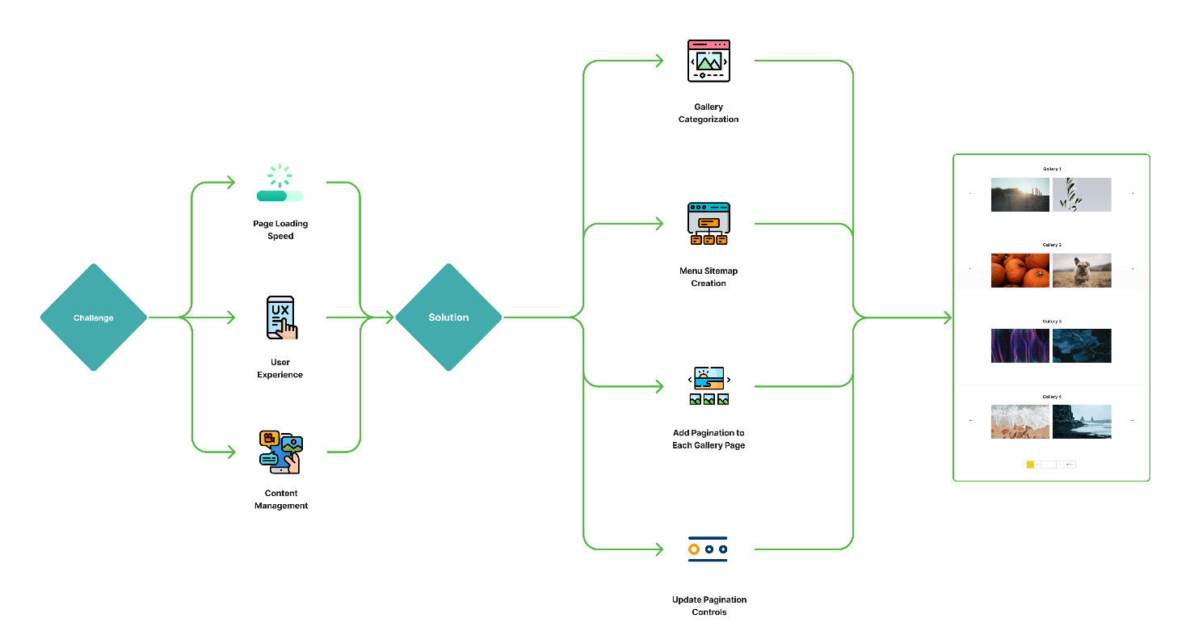

Designing the solution architecture for "Creating a Sponsored Post for Instagram" involves defining the overall structure, components, and interactions of the system. Here's a high-level solution architecture for such a project:

1. **User Interface (UI):**

Web Application: The user interacts with the platform through a web application that provides a user-friendly interface for creating and managing sponsored posts.

1. **Front-end:**

* **Front-end Framework:** Utilize a modern JavaScript framework like React, Vue.js, or Angular for building the user interface.
* **User Authentication:** Implement user authentication for secure access to the platform.
* **Content Creation:** Allow users to create, design, and schedule sponsored posts using a user-friendly interface.
* **Hashtag Management:** Provide tools for users to manage and select relevant hashtags.
* **Audience Targeting:** Incorporate features to define and target specific audience segments.
* **Analytics Dashboard:** Create a dashboard for users to monitor post performance, engagement, and reach.
* **Payment Integration:** Implement secure payment processing for businesses to promote posts.

3. **Back-end:**

* **Back-end Framework:** Use a server-side framework like Node.js, Ruby on Rails, Django, or Spring Boot.
* **API Layer:** Develop RESTful APIs to handle user requests for tasks such as post creation, scheduling, analytics, and user management.
* **User Authentication:** Implement user authentication on the server-side to ensure secure access.
* **Database:** Utilize a database management system (e.g., PostgreSQL, MongoDB) to store user data, post information, and analytics data.
* **Instagram API Integration**: Integrate with the Instagram API to enable post scheduling, data retrieval, and interactions with Instagram features.
* **Payment Processing**: Implement secure payment processing, if required, to allow businesses to promote posts.
* **Security Layer**: Implement security measures, including data encryption, access controls, and protection against common web vulnerabilities.
* **Scalability**: Design the back-end to be scalable and capable of handling a growing user base.

4. **Database:**

* **User Data Storage:** Store user account information, profiles, and preferences.
* **Post Data Storage:** Save sponsored post content, scheduling information, and associated data.
* **Analytics Data:** Store post performance metrics, engagement data, and user interactions.

**5. Cloud Hosting:**

* Host the application on a cloud platform (e.g., AWS, Google Cloud, Azure) for scalability, reliability, and ease of management.
* Use cloud resources to handle varying levels of traffic and to ensure high availability.

**6. External Integrations:**

Integrate with third-party services, such as payment gateways, email services, and social media APIs, as needed.

**7. Monitoring and Analytics:**

* Implement tools and services for monitoring the application's performance, security, and user interactions.
* Set up analytics to gather data on user behavior and post performance

.

**8. Security and Privacy Considerations:**

Ensure that the architecture complies with relevant data protection and privacy regulations.

Implement security measures to protect user data, payments, and overall system integrity.

**9. Continuous Improvement:**

Establish processes for collecting user feedback and making continuous improvements to the platform.

**10. Load Balancing and Scaling:**

Implement load balancing to evenly distribute incoming traffic across multiple server instances.

Design the system to be scalable, allowing for efficient resource allocation as the user base grows.

**11. Disaster Recovery:**

Set up backup and disaster recovery solutions to ensure data integrity and business continuity.

This architecture provides a high-level view of how the components of the system interact to create a sponsored post for Instagram. Depending on specific project requirements and technologies chosen, the architecture can be adapted and expanded to meet the project'sunique needs..